When using the <http://wecantspellsuccesswithoutyou.com> website we can click the “Food Challenge – Brand V Brand” area and click on various foods that shows how different brands can impact on your health. Once the food is selected a document will open you can compare many brands showing Calories, Saturates and Carbohydrate where the lower the number in each category reflects the following:

Calories Select the food with the lowest number if you want to lose weight

Select the food with the higher number if you want to gain weight

Saturates Select the food with the lowest number you are concerned about cholesterol or if

You suffer from heart disease

Carbohydrate Select the food with the lowest number you are concerned Diabetes Types 1 and 2

Sometimes when we select the food we are interested in the following message appears:



This simply means this type of food hasn’t been documented at the moment, but also invites you to research and provide this information so you and other people using this web site can share and benefit from this information.

This document is intended to make this process easy by showing how food information is collected and presented in the format that the web site uses and people can easily understand.,

This is done using the following the following steps shown on the next few pages.

**Preparation**

Step 1.1

Click on Downloads button and click on food calculator, this will download and open a food calculator as an excel spreadsheet.

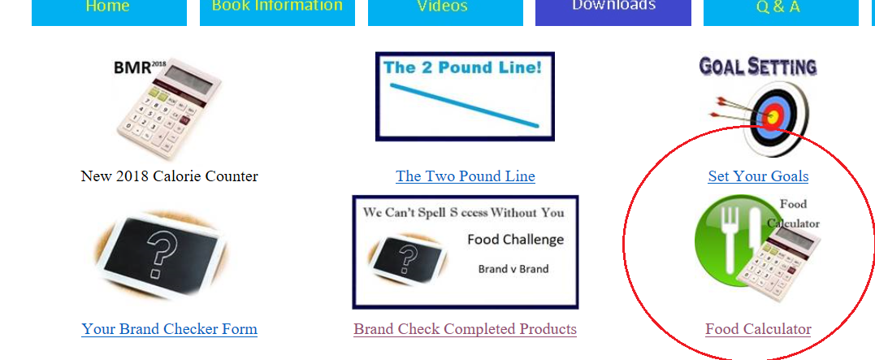

Once downloaded you must click on enable editing so it can be saved on your PC and edited later. The spreadsheet downloaded should look like:

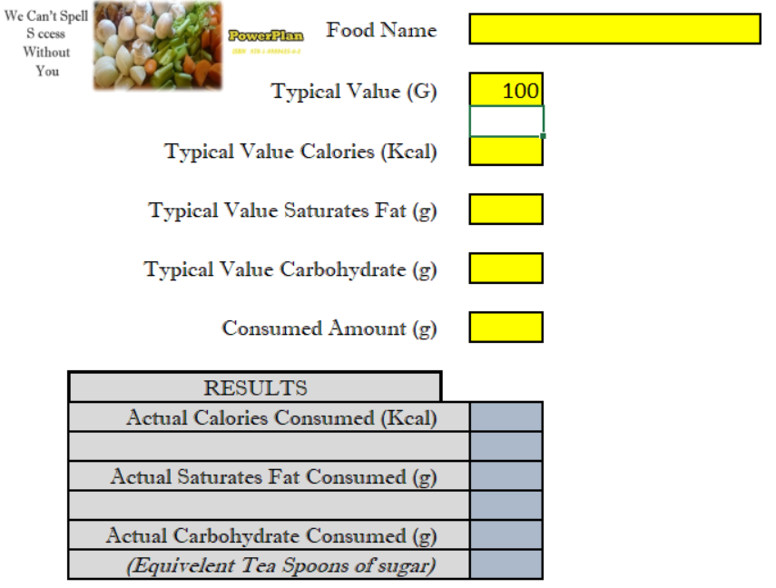

Leave the spreadsheet open as we will go back to it later in this guide.

Step 1.2

Click on Downloads button and click on your brand Checker Form, this will download and open a blank brand v brand compare form.

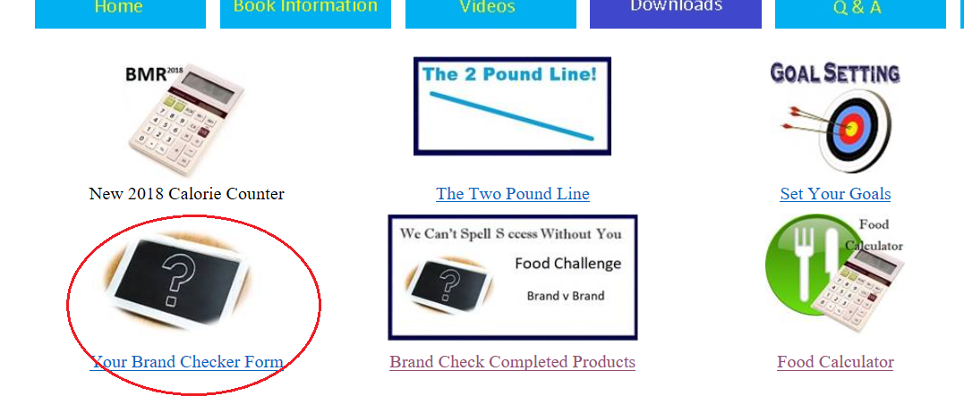

Once downloaded you must click on enable editing so it can be saved on your PC and edited later. The document downloaded should look like:

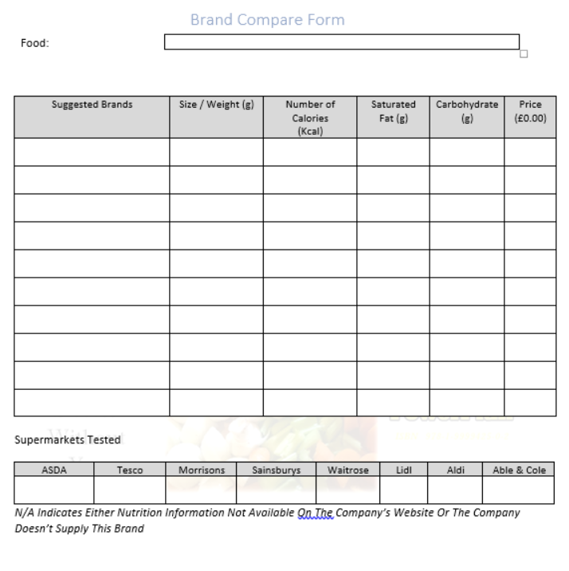

**Research**

Now we need to decide which food that you want to enter, for this demonstration I am going to research **all day breakfast** readymade meal.

2.1

First thing we need to do is Enter all Day Breakfast on the document:

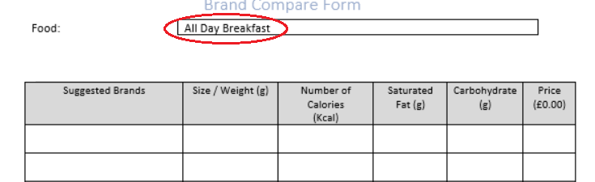

2.2

Now select file and save as to save the document on your computer, I will use file name “Brand Compare All Day Breakfast.docx” so I can recognise it later.



2.3

Next log online to your favourite supermarkets web page, I tend to use the following:

[www.asda.com](http://www.asda.com)

[www.tesco.com](http://www.tesco.com)

<https://groceries.morrisons.com/webshop/startWebshop.do>

[www.sainsburys.co.uk](http://www.sainsburys.co.uk)

[www.waitrose.com](http://www.waitrose.com)

[www.myfitnesspal.com](http://www.myfitnesspal.com) (for Lidl & Aldi)

[www.abelandcole.co.uk](http://www.abelandcole.co.uk)

If you log onto ASDA as an example enter the food name in the search area of the web site and press enter on your keyboard:



2.4

Various items are shown for sale but I just want to log the readymade meals that are available:

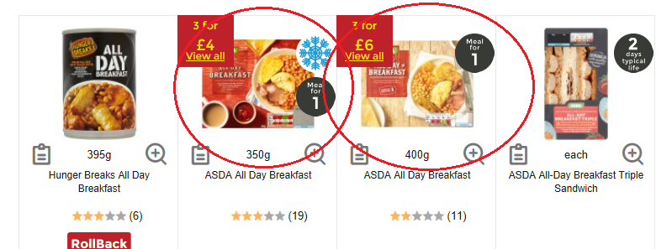

At this point we can update our brand v brand document with the name of the brand (red circle), overall weight (Green circle) and price (blue circle):

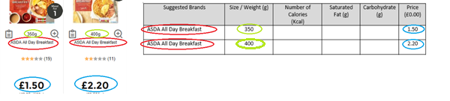

2.5

Next, we need to find the 100g nutrition value of each of our logged products, simply click on the food and look down the web page until you find nutrition. Once found we need to concentrate on Calories (Kcal), Saturates(g) and Carbohydrate (g) in the 100g section, for example shown in red of the 350g ASDA all day breakfast:

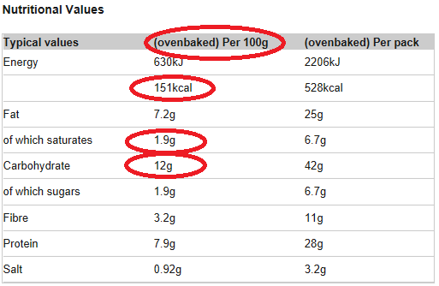

2.6

These 100g values we need to enter in the spreadsheet we down loaded earlier, the 100g is already set so we need to Food Name (optional), Calories (Kcal), Saturates(g) and Carbohydrate (g):

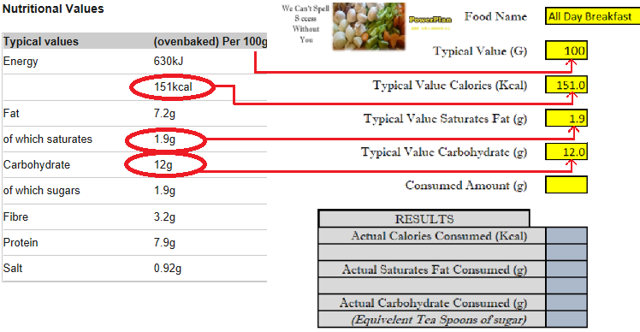

2.7

Now if we enter the size of the product in grams as “Consumed Amount (g)” we are presented with total amounts of Calories (Kcal), Saturates(g) and Carbohydrate (g) contained in the product:

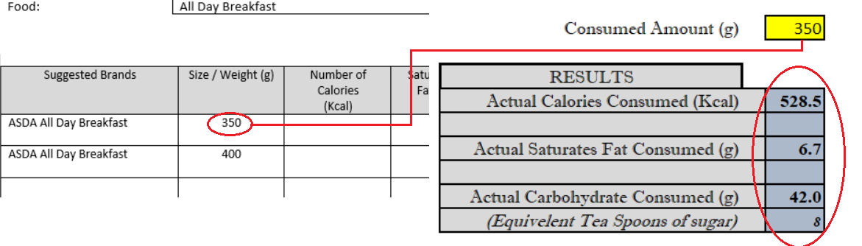

2.8

Finally, we can copy these values on our Brand v Brand document so we have the full values of what the food contains:

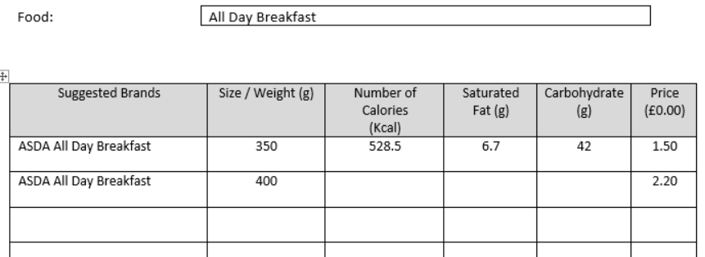

Now you can repeat the actions for each brand following these instructions from step 2.3 to gain a full comparison of the products listed by brand for each supermarket, remember to mark the supermarket tested once you have finished:

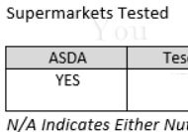

You can also enter N/A if either nutrition information not available on the company’s website or the company doesn’t supply this brand. For example, Sainsburys only sells tinned all day breakfast so NA is entered!!!!

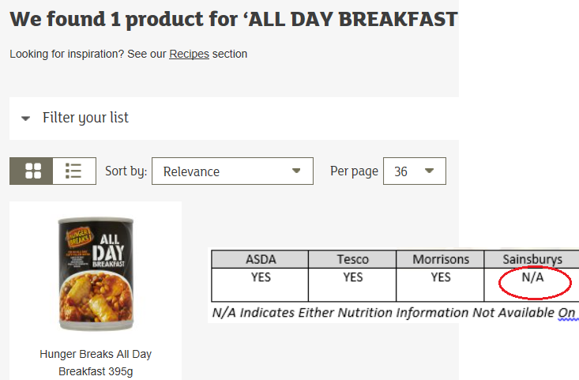

**Finishing Off**

3.1

Once you have logged the food from each of the supermarkets REMEMBER to save your document as you won’t want to lose it! It should look similar to the one shown below:

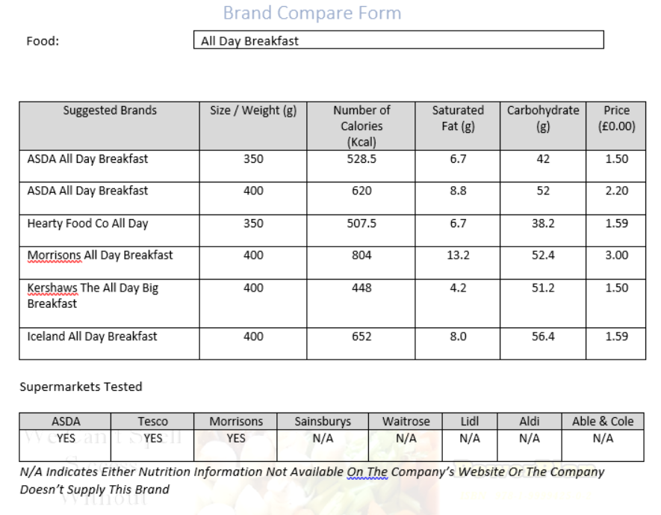

Now you see all the information across the brands so you are able to choose the correct brand for you rather that getting your favourite brand or the cheapest one that might be harmful to your health over time.

Also you can share your completed form with others by simply emailing it to [wecantspellsuccesswithoutyou@gmail.com](mailto:wecantspellsuccesswithoutyou@gmail.com) and it will be load on the [WWW.NADIET.INFO](http://WWW.NADIET.INFO) website!!

**Note**

The provided list of supermarkets is only an example of popular shops in my local area. Feel free to add additional relevant items from other retailers such as Iceland, Co-op, Home and bargain, etc if you feel that this would create a more informative result.

******* END OF DOCUMENT ******